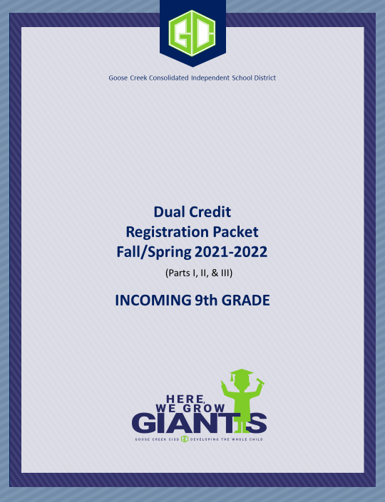

GCCISD Dual Credit Registration Packet Part I
Incoming 9th Grade students
2021-2022

Dual credit is the process by which a high school student enrolls in a college course and receives simultaneous academic credit for the course from both the college and the high school. To enroll in a Dual Credit course, the student must complete a series of steps that are involved in the registration process. One of these steps includes parental permission to enroll in a Dual Credit course through Goose Creek CISD. Prior to granting your written permission to enroll your child in a Dual Credit course, please be advised of the following important information:
- In order to be eligible to receive high school credit for a Dual Credit course, a GCCISD incoming 9th grade student must have first met with his/her 8th grade counselor, received written approval through the counselor to take the course, and written approval from the parent/guardian for the student to register for the course.
- To register for a dual credit class, an 8th grade student must complete the steps that are listed on the last page of this packet. The steps include taking the reading and writing sections of the Texas State Initiative (TSIA2) Assessment. It also includes completing all required paperwork per the deadline date. Incoming 9th graders must take the TSIA2 at Lee College.
- Grades are confidential, only available to the student, unless the student signs a FERPA release form through Lee College.
- Students are required to use the online “myLC” account provided by Lee College to access grades and etc. It is the responsibility of the student to access the system and learn how to use it.
- Six-week report card grades are not provided.
- For Dual Credit courses taken during regular high school hours, a nonrefundable fee in the amount of $50 must be paid to Goose Creek CISD. The $50 fee will be collected at the high school level upon enrollment in a dual credit course. GCCISD will fund the remainder of the course tuition/fees as well as the cost of the textbook(s). For courses taken outside of regular high school hours, the total course fee/tuition as well as the textbooks is the responsibility of the student/parent.
- Beginning with the 2016-17 ninth grade class (Cohort 2020), dual credit courses taken outside of regular high school hours (evening, summer, etc.) will not count towards academic class rank.
- Dual credit courses may meet two to three times a week on GCCISD campuses.
- Some Dual Credit courses may contain subject matter that is of an adult nature.
- A letter grade will be recorded on the permanent college transcript and a numeric grade on the high school transcript.
- Students who receive a final grade below a “C” will not be allowed to progress to other Dual Credit courses without repeating the previous course successfully.
- Dual credit teachers may be GCCISD teachers, who serve as Lee College adjunct professors, or they may be non-GCCISD employees who are Lee College professors.
- If a Dual Credit course does not make based on enrollment requirements, (although every effort will be made to place a student into a comparable course with weighted credit) please be aware that there is a chance that a student may be placed into a course that does not carry weighted credit. Also, please note that the availability of the class is also dependent upon availability of Lee College professors to teach the course.
- Dual Credit courses are college level and taught by college approved instructors. Students with disabilities must meet with the Counselor for Students with Disabilities at Lee College in order to be considered for accommodations in courses. This is the responsibility of the student.
- Prior to withdrawing from a college dual credit course, it is the student’s responsibility to first discuss this matter with his/her high school counselor to determine if space is available in a comparable high school course. Certain restrictions and consequences are in place regarding withdrawing from a college course. For more information, contact the Lee College Dual Credit Director of Dual Credit.
I have read these guidelines and wish to proceed forward with the Dual Credit registration process. By typing my signature below, I also agree to allow GCCISD to release my child’s Meningitis vaccine records to Lee College, if necessary.
Student’s Signature: Date:
Parent’s Signature: Date:
GCCISD Dual Credit Registration Packet Part II
Incoming 9th Grade Students
2021-2022

Student Name: High School ID#: Lee College ID#: Student Birthdate: mm/dd/yyyy
Graduation Cohort: Jr. School you attend: High School you will attend: Semester

To register for a Dual Credit course, students must:
- Meet with your 8th grade counselor to begin the GCCISD Dual Credit Registration Process. Your counselor will
provide you with a GCCISD 9th Grade Dual Credit Registration Packet.
- Complete the registration steps listed on the last page of this packet.
- Submit the signed GCCISD 9th Grade Dual Credit Registration Packet to your 8th grade counselor.

Dual Credit Course Options for 9th Grade students 2021-2022
Check the box for the course you wish to take | College Course | Course # | High School Course | PEIMS Service ID#
 | Learning Pathways | EDUC 1200 | College Readiness and Study Skills | 03270100
 | Personal Health | KINE 1304 | Health | 03810100
 | Public Speaking | SPCH 1315 | Principles of Public Speaking | 03240900
 | Business & Professional Speech (Note: If you are working towards a degree in Logistics, take this speech course) | SPCH 1321 | Professional Communications | 13009900
 | Business Computer Applications  (Note: This course applies towards technical degrees/certificates) | BCIS 1405 | Business Informational Management I | 13011400
 | Beginning Spanish I | SPAN1411 | Spanish II A | 03440200
 | Beginning Spanish II | SPAN 1412 | Spanish II B | 03440200
For 8th Grade Counselor Only
Pending parental approval, the above listed student has my approval to begin the registration process for the indicated dual credit course with Lee College and receive high school credit upon passing the course.
8th Grade Counselor Signature: TSI Requirement met: Date:
For Student’s Only
I give permission to release my future dual credit grade(s) to my high school.
I give permission to my school to release standardized test scores to Lee College, if necessary, to determine course eligibility.
Student’s Signature: Date:
I would like to receive information regarding services for students with disabilities.

For Parent/Guardian Only
By signing my signature below, I give my child permission to take the above course. After having read and signed Part I of the 9thGrade GCCISD Dual Credit Registration Packet, I am aware that some college level courses may contain subject matter that is of an adult nature.
Parent’s Signature: Date:

Once all steps of the registration process have been completed, this signed form must be returned to the student’s 8th grade counselor no later than March 31, 2021

GCCISD Dual Credit Registration Process
Incoming 9th Grade Students

Step 1: Meet with your 8th grade counselor in order to begin the GCCISD Dual Credit Registration Process. The counselor will also provide you with a GCCISD 9th Grade Dual Credit Registration Packet.
Step 2: Complete an online application for Lee College at www.applytexas.org.

Step 3: Once an application has been completed, Lee College will issue a student ID number which will be emailed to the e-mail address used on the Apply Texas application.

Step 4: Complete the Pre-Assessment Activity (PAA) at: https://www.lee.edu/counseling/paa/index.php. Students must use their Lee College ID number to complete the PAA. The PAA must be completed prior to taking the Texas State Initiative (TSIA2) Assessments. The TSIA2 assessment is utilized to determine college readiness.

Step 5: The TSIA2 assessment consists of 2 sections, reading/writing, and math. Incoming 9th grade students will need to take the reading/writing section of the TSIA2. Results are available immediately after testing.

Step 6: Contact the Dual Enrollment Office via email at dualenrollment@lee.edu to determine testing needs.

Step 7: Submit all of the following to the Lee College Admissions/Records Office:
- FERPA Release Form, complete with student, parent and school official signatures
- Proof of Meningitis vaccination (if taking classes on LC campus)

Step 8: Complete the GCCISD 9th Grade Dual Credit Registration Packet and return the signed packet, with parental signature included, to your 8th grade counselor no later than March 31, 2021. [In order to facilitate the scheduling process, Grade 8 counselors are responsible for submitting all completed registration packets to the High School College & Career Readiness Counselor by March 31, 2021.]
Step 9: Once Steps 1 through 8 have been completed, the Lee College Dual Enrollment Office will handle the registration of students. Registration is dependent upon a number of factors such as meeting the minimum TSIA2 required score, all required paperwork completed, and etc.
NOTES:
- The $50 nonrefundable will be collected at the high school level upon enrollment in the course. GCCISD will be paying the remainder of the course tuition/fees as well as purchasing and acquiring the textbooks for the course. Lee College will be paying for the first administration of the TSI assessment per student.
- Students must sign the FERPA (Family Educational Rights and Privacy Act) Form with Lee College for the parent to have access to information such as grades, college account, transcript, etc.

Dual Enrollment
TEXAS SUCCESS INITIATIVE (TSI) REQUIREMENTS FOR DUAL ENROLLMENT
STAAR  EOC Exams* |  | Algebra I EOC 4000  and C or better in Algebra II
TSI Assessment | Scores are based upon the course you are registering for. Please see high school counselor or Dual Enrollment Advisor. These scores are valid for 5 years from date of test. | Scores are based upon the course you are registering for. Please see high school counselor or Dual Enrollment Advisor. These scores are valid for 5 years from date of test.
TSIA 2 Assessment | Scores are based upon the course you are registering for. Please see high school counselor or Dual Enrollment Advisor. | Scores are based upon the course you are registering for. Please see high school counselor or Dual Enrollment Advisor.
*Only used for Dual Enrollment purposes.
REFERENCES
Texas Administrative Code, Rule 4.53
Texas Administrative Code, Rule 4.54
Texas Administrative code, Rule 4.57

